Influence of maladaptive migrants on a dying population

Florin Suter, Balz Fuchs, Felix Rentschler

**Abstract**

Evolutionary rescue is a process, in which doomed populations might avoid extinction through adaption by natural selection (Bell, 2017; Gomulkiewicz et al. 1995). Consider a scenario where a threatened population could adapt through a single beneficial mutation, yet faces geneflow from migrants carrying the maladaptive genotype. How are the migrants influencing the extinction-probability and how big is the probability of rescue for the doomed population under these circumstances? After we programmed our model and gathered a lot of data, we found, that only under low migration the population would get rescued, under medium migration extinction probability is highest and with high migration the population is able to persist a certain level. Note that we chose the mean migrants per generation between 0-10 and got such different results. So doomed populations are very sensitive and even the smallest changes can influence them strongly.

**Introduction**

In conservation we often see introduction of migrants as a way to save a doomed population (Alexander et al. 2014). There are many examples of this as for example the rescue of the Florida panther (Puma concolor coryi) population by introducing panthers from other regions to increase the populations gene pool and thus rescue them from inbreeding depression (Pimm et al. 2006).

However, in this model we thought about a diploid population (aa) that is maladapted to its environment and can only become a growing population by acquiring a certain beneficial recessive mutation (AA). Note that usually recessive alleles are referred to with a small letter but here the dominant allele is called “a” and the recessive allele “A”. Our hypothetical scientists are attempting to save the population by introducing migrants from a source population that doesn’t carry the beneficial allele and thus is maladaptive. In our model we hoped to see the impact of a migrating deleterious genotype on the extinction and rescue probabilities of our population. So, we formulated these two biological questions:

* How does migration of a deleterious genotype influence extinction probability of a diploid population?
* How big is the probability for a diploid population to be rescued with migration of a maladaptive genotype?

We hypothesized that the probability of rescue would be higher under low and high levels of migration compared to moderate levels, and vice versa for the extinction-probability. We thought that a small number of migrants would still lead to evolutionary rescue. But even slight increases in this number would lead to too many individuals with maladapted genotypes per generation, so that the mutants cannot take over and the population would die out. However, high migration numbers/generation could stabilize the population and increase the chance of evolutionary rescue again. This hypothesis would show a contrasting result to the model Uecker et al. developed in 2013, this could be feasible, because contrasting to our model they used migrants with the beneficial genotype.

**Methods**

For this model all coding was done using the language r. For the code base r was sufficient however for the visualization of the results packages such as ggplot were used to increase legibility.

Source code

The base source code used for the further coding of the model was provided by the theoretical ecology and evolution (TEE) research group. The code models a doomed population that will go extinct but can be rescued by the fixation of a beneficial mutation. It simulates this for as many generations as are input. The source code can be found on the TEE teams platform. The rest of the code was written by us.

Simulation of one generation

Parameters:

N_aa = 1000

N_Aa = 0

N_AA = 0

Fitnessaa = 0.9

FitnessAa = 0.9

FitnessAA = 1.1

Avgmigrants = 0,1,2,3,4,5,6,7,8,9,10

Mut_rate = 0.0005

In a first step one generation has to be simulated. As the population is diploid there are three starting populations that are set as N_aa = 1000, N_Aa = 0, and N_AA = 0. As there is a fitness difference between the different genotypes these had to be defined as well. For the fitness of the different genotypes we chose fitnessaa = 0.9, fiitnessAa = 0.9, and fitnessAA = 1.1. Both the selection coefficient and the decay rate are contained in the fitnesses in order to keep the number of parameters to a minimum. The next parameter is avgmigrants. This parameter represents them mean number of migrants that enter the system in the given generation. Here it is important to note that this is the parameter that is varied. We tested the model with zero to ten migrants. The genotype of these migrants is always the maladptive aa genotype. The final parameter defined for this function is the mutation rate mut_rate = 0.0005. This mutation rate was chosen arbitrarily in a way that the average number of mutants per generation isn’t over one.

The function assumes a Hardy-Weinberg equilibrium. The parts of the code dealing with this will be described below. Some variables are mentioned below and are not explained. For these please see the code provided in the attachment.

1. The total number of a and A alleles are calculated:
2. Number of mutations from A to a and back are calculated:
3. p and q are defined as:
4. Calculate frequency of the genotypes in the next generation. This is where selection takes place

*det_aa_next = (p^2)*fitnessaa/avg_fit*

1. Draw the true number of offspring. The number stored in next_gen_tot_pop is the deterministically calculated population size for the next generation. Note that migrants are only added to the aa offspring as this is the maladaptive genotype.

*offsp_aa = rpois(1, next_gen_tot_pop*det_aa_next) + aa_migrants*

*offsp_Aa = rpois(1, next_gen_tot_pop*det_Aa_next)*

*offsp_AA = rpois(1, next_gen_tot_pop*det_AA_next)*

Simulation of population until one of three conditions is reached

Parameters:

N_init_aa = 1000

N_init _Aa = 0

N_init _AA = 0

Fitnessaa = 0.9

FitnessAa = 0.9

FitnessAA = 1.1

Avgmigrants = 0,1,2,3,4,5,6,7,8,9,10

Mut_rate = 0.0005

T_max = 10’000

Here the code is run until one of three conditions is reached. The first condition is that the population reaches 1.5 times its starting size. This is seen as successfully escaping extinction and becoming a growing, self sustaining population. The second condition is that the population goes extinct. As a population with a continuous stream of incoming migrants never stays at zero individuals for long, extinction is defined as 10* the number of migrants per generation. The final condition that can be reached is that the population surpasses t_max = 10000 generations. This is a fail safe that ensures that the simulation stops at some point and does not run indefinitely.

This function contains most of the same parameters as the function explained above. As this function runs for more than just one generation the labels for N_aa, N_Aa, and N_AA have been changed to N_init_aa, N_init_Aa, and N_init_AA. The only new parameter is the before mentioned t_max which represents the maximum number of generations that the model should simulate. The important steps of the function will once again be outlined below. As before some steps will be left out and can be found down below in the attachment.

1. The for-loop runs for t_max generations generating t_max generations which are continuously added to one matrix: pop_vector.
2. Next we have an if command. This loop breaks off the simulation if a population size is generated, that is more than 1.5 times the size of the initial population size.
3. The final else if command breaks of the simulation if the minimal populations size goes below the threshold of 2*avgmigrants at which point the population is assumed to be functionally extinct.
4. When the function breaks down, a value of 1,2 or 3 will be put at the end, to signal how the for loop was ended.

To analyze the influence of migration on the outcome we simulated the population for each migration (0,1,2,...,9,10) value 2’000 times. To compare our results with dominant or heterozygote intermediate mutations we also simulated these 2’000 times for each migration value. Because we inspected something strange at around 5 migrants per generation, we repeated the simulations of 3 to 7 migrants per generation another 10’000 times.

**Results**

In general, it was shown, that the more immigrants there are, the more likely it was that the population could persist. However, it was also shown that the probability for the population to grow on its own decreased as more migrants were introduced per generation (*Figure 1*). The 10’000 extra repetitions for mean migrants 3-7 showed a similar pattern, where persistence increases with more migrants and rescue and extinction probabilities decrease (*Figure 2*).

The final population size is at low migration values either at the extinction threshold or at the defined maximum. With mean immigrants per generation passing 5 it shows another stable state at around 10*average migrants. This outcome happened at the most extreme with 10 migrants per generation where only 1 population went extinct, and all the others stayed around 10 * 10 = 100 (*Figure 3*).

The final allele frequency shows a pattern where the mutant allele only got fixed in the populations which reached the maximum. And in the populations with immigrants, complete fixation never happened (*Figure 4*).

The time to reach the maximum increased when more migrants were coming in per generation, until no populations reached the maximum at all (*Figure 5*).

With heterozygote intermediate fitness and the scenario with a dominant beneficial mutation the extinction probability decreased and the outcome to be at an intermediate state was non-existent (*Figure 6*).

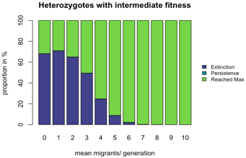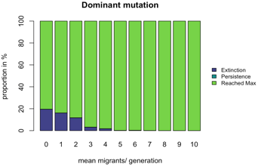

Figure 6: The model with heterozygotes with intermediate fitness (top) and the model with the mutation being dominant. All other parameters stay the same.

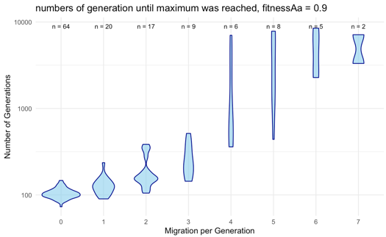

Figure 5: Number of generations until maximum is reached for 0-7 migrants per generation

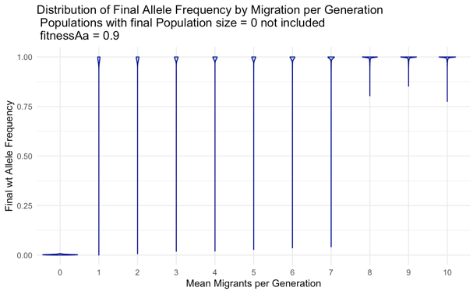

Figure 4: Distribution of final allele frequencies by migration per generation excluding populations with a final population size of 0

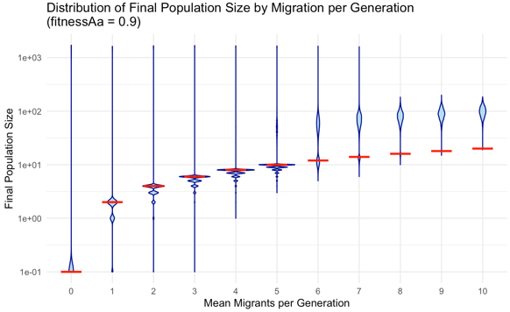

Figure 3: Distribution of the final populations size by migration per generation. The red line denotes the threshold under which a population was considered extinct.

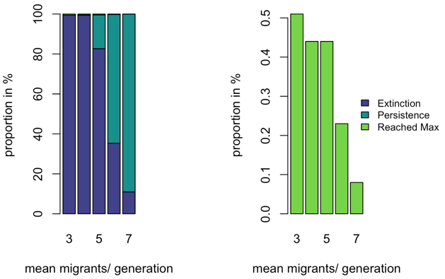

Figure 2: Same graphs as figure 1 but with only migrants 2-7. Here we simulated 10’000 repetitions.

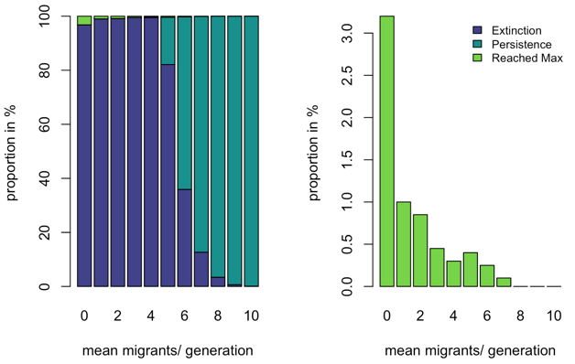

Figure 1: The graph (left) shows the relative amount of simulated populations that reached each of the three predefined conclusions. The graph on the right highlights the percentage of populations for each number of migrants that reached rescue.

**Discussion**

Now we come to the discussion. As a reminder we will reiterate our biological questions:

1. How does migration of a deleterious genotype influence extinction probability of a diploid population?

2. How big is the probability for a diploid population to be rescued under the influence of the migration of a maladaptive genotype?

The first graph (*Figure 1*) already gives a lot of information to answer these questions. As mentioned in the methods section the graph depicts the proportion of runs that reached each of the three break-off states for 0-10 migrants. As can be seen in the graph on the left, the probability of the population being rescued (the mutant genotype taking over) is very low and only seems to happen with any consistency at very low levels of migration. To show the true extent of rescue we decided to extract the rescued populations and visualize these in a second graph (right). As is made clear, the percentage of rescued populations is very small at low migration levels and nonexistent in populations that experience on average more than seven migrants.

In *Figure 1* we noticed an interesting pattern. The rescue probability seems to rise slightly around five migrants. Although the chances of this being a meaningful pattern seemed quite small because only 8 populations reached the maximum (which could be due to chance), we decided to test this phenomenon. To do so the simulation was rerun and only the outputs for 3-7 migrants per generation were graphed. As is made clear by the graph there is probably no causation for the slight increase in rescue probability seen above except for stochasticity (*Figure 2*).

As *Figure 1* shows, the populations, especially at high migration rates, never reach extinction or carrying capacity. This led us to believe that these populations are so called sink populations that are only viable because of the incoming migrants. An interesting thing to study in this regard is the size of these populations. As we defined extinction as 2 * mean migrants per generation we created a graph to show us how much above the extinction threshold (red line) the populations lie. As can be seen in the graph (*Figure 3*), the population sizes are very variable at low migration rates. This is because some populations are rescued. As the number of migrants increases, the spread of population sizes becomes much more uniform as the average population size starts to hover around 100 individuals. This happens due to the defined decay rate being 0.1 (fitnessaa – 1) which can be compensated when migration is at 0.1 * N. Thus, leading to a dynamic stable state.

As we were interested in a diploid population, we wanted to visualize the allele frequencies in the populations. This allowed us to see if the populations allowed for any real presence of the mutant allele or if it couldn’t really find any purchase in the populations. The graph only shows the allele frequencies of the populations that had a final population size >0 (*Figure 4*).

As can be seen in the graph, the populations with no migrants are made up of entirely mutant alleles. This is as expected because the populations have to mutate in order to survive. As we start to introduce migrants it becomes clear that the distribution of alleles is a lot more varied. It comes as a bit of a surprise to us that there seem to be more wt alleles in the populations that survive. As the migration reaches the critical amounts of 8-10 we see the that the mutant allele can never really find any purchase. However, it is also never completely eradicated and still makes up roughly 15% of the alleles. It would be interesting to continue the simulations with even more migrants and see if the mutant allele frequencies always hover around 15% or if its frequency declines even further. We hypothesize that the mutant allele fails to increase because it never reaches a high enough frequency for its fitness advantage to drive its frequency higher in the next generation. This functions as followed:

Next generation allele frequency

Fitness of the genotypes

Average fitness

Allele frequency mutant

Allele frequency wt

If the change in allele frequency () is not high enough, the immigration of individuals with wildtype genotypes (aa) will be able to set mutant allele frequency back to the same or lower allele frequency. The effective allele frequency of the mutant allele is therefore influenced by the number of migrants, that got in:

Number of migrants that entered the population

Population size in this generation (migrants are included!)

Our model also allowed us to generate a graph with the generation at which the maximum was reached (*Figure 5*). It is important to note that this graph only goes up to 7 migrants per generation because after that, no more generations reach the maximum. It is pretty clear that the time to maximum increases with incoming migrants. This shows that the migration of the dominant, deleterious genotype is bad for the survival of the population. An interesting phenomenon is that at lower (0-3) migrants there seems to be a specific number of generations at which the most populations reach rescue. This pattern isn’t seen for larger migration rates. It could be that at higher migration rates the chance of rescue is completely random, as would be supported by the huge difference in the number of generations until rescue or that we just don’t have enough datapoints to generate such averages.

We didn’t just simulate the scenario with a recessive mutation, but also with heterozygote intermediate and a dominant mutation.

In both cases we see a large increase in the number of populations that reached the maximum population size (*Figure 6*). The populations that reach t_max that were so prevalent in our original model (*Figure 1*) have completely disappeared.

It was very surprising to us how much of a difference it made to the outcome to have the heterozygotes have an intermediate fitness. The reason for this is that there is selection towards the heterozygote, not only the homozygote which is frequency dependent and mostly only occurs at higher allele frequencies.

**Conclusion**

Our results showed certain differences to our hypotheses. While we predicted that there would not be large differences in rescue probabilities between low and high migration-rates, the results showed that evolutionary rescue is only possible at very low migration-rates but even then, very unlikely. Populations with high migration-rates stabilize but are no longer rescued or go extinct. That an intermediate migration-rate increases the probability of extinction and evolutionary rescue becomes very unlikely was somewhat confirmed by the results.

So, if you want to start conservation actions on a population with a recessive rescue mutation, the number of migrants per generations should be chosen rather conservatively.

**Limitations**

We are aware that we are in a very small niche with this model, of course it makes more sense for conservation actions to let the mutants migrate. Also, the risk is probably lower because, as we have seen, small differences in the migration-rates in our model can greatly increase the extinction-probability for the population. We also focus here on fixed fitness numbers and thus never change the decay rate. We also don't know what the whole thing would look like if we were to add a carrying capacity.

**Literature**

Alexander HK, Martin G, Martin OY, Bonhoeffer S;  2014; Evolutionary rescue: linking theory for conservation and medicine.

S. L. Pimm, L. Dollar, O. L. Bass Jr; 2006; The genetic rescue of the Florida panther

Graham Bell; 2017; Evolutionary Rescue

Richard Gomulkiewicz, David Houle. 1995. Demographic and Genetic Constraints on Evolution

Hildegard Uecker, Sarah P. Otto, Joachim Hermisson; 2013; Evolutionary Rescue in Structured Populations